Kokand Team
Team Members
- Ibragimov Umarjon 2217667
- Nabiev Azamat 2217423
- Egamberdiev Shuhrat 2217575
- Toshtemirov Ulugbek 2217841
- Yuldashev Shavkatjon 2217071
- Islamov Ilyosbek 2217619
- Aakash Thapa 2217494

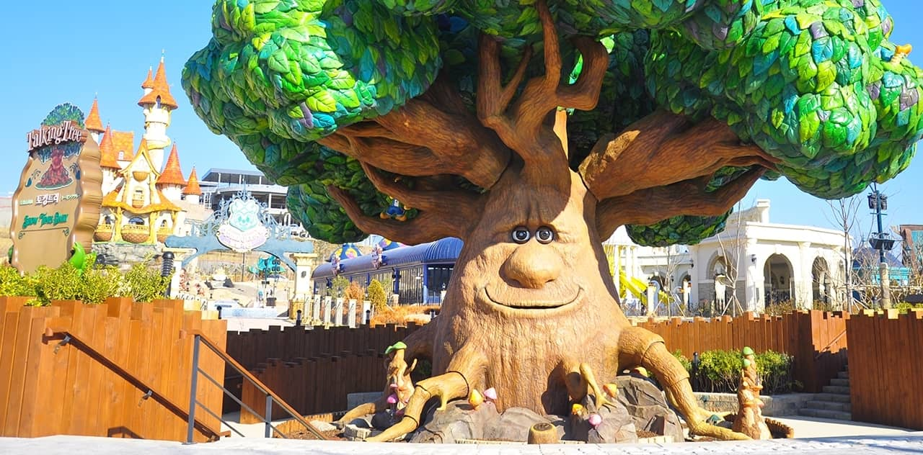

Introduction
CONA Analysis for Busan Lotte World

This report takes a unique approach using CONA methodology, where we dig into online reviews to unravel the secrets behind what people love about Lotte World in Busan.

Located in the vibrant city of Busan, South Korea, Lotte World Adventure Busan is a haven for adrenaline lovers and families alike. This exciting theme park, opened in 2022, offers a unique experience with its cutting-edge attractions and diverse entertainment options.

By running this research through these digital conversations, we are about to uncover some factors that bring joy to visitors. We analyse the collective experiences shared by the online community( google maps comments ), aiming to show a vivid picture of what truly sets Lotte World apart as a destination liked by many.

CONA Analysis

of Lotte World Busan Online Reviews:
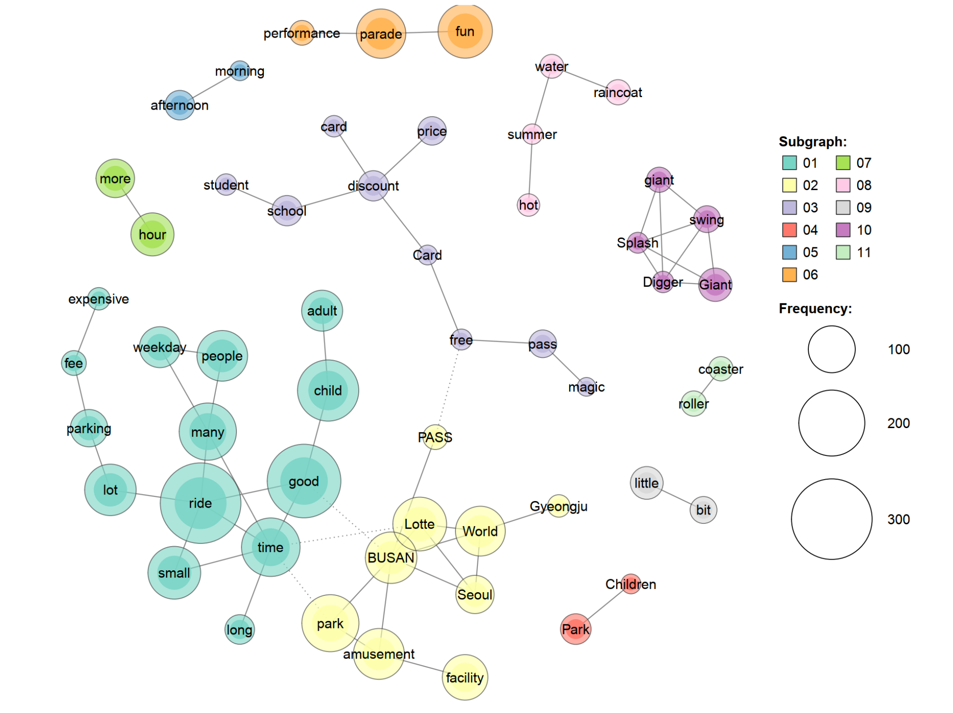

FINDINGS

Cluster 1

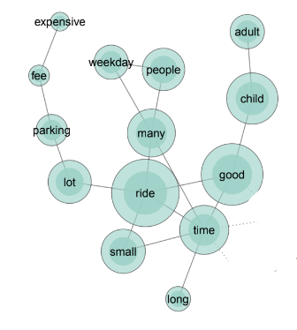
Children have a good time at Busan Lotte World, but the lines can be long, especially on weekdays. The parking fee is also expensive. Overall, the first cluster suggests that Busan Lotte World is a good place to take children for a fun day of rides.

Cluster 2
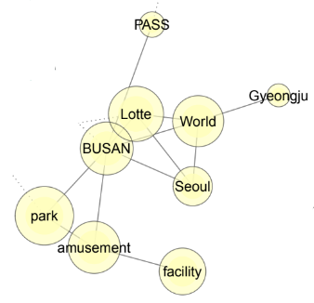
Busan Lotte World is an amusement park facility offering various passes. Some users compare it to another amusement park in Seoul, Gyeongju, potentially exploring travel options between these locations.

Cluster 3

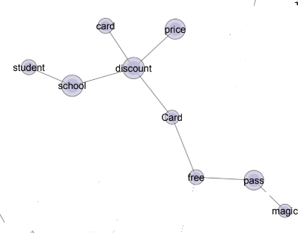
Busan Lotte World offers special discounts and passes for students and school groups. These discounts can be significant, making it a more affordable option for families and educational trips. The use of a specific card or pass might be required to obtain the discount.

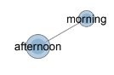
Cluster 4
The next cluster reveals trends in visiting times, indicating a preference for afternoon visits over mornings among people.
Cluster 5


The parades and performances at Busan Lotte World are a lot of fun and contribute to the overall positive experience of the park.

Cluster 6
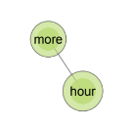
This cluster suggests that visitors to Busan Lotte World should be prepared for long wait times for rides, especially on weekends and holidays.

Cluster 7
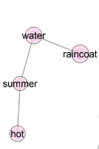
During the hot summer months, the water rides at Busan Lotte World are a popular attraction. However, it is important to be prepared for getting wet, as raincoats are recommended.

Analysing by Review Ratings

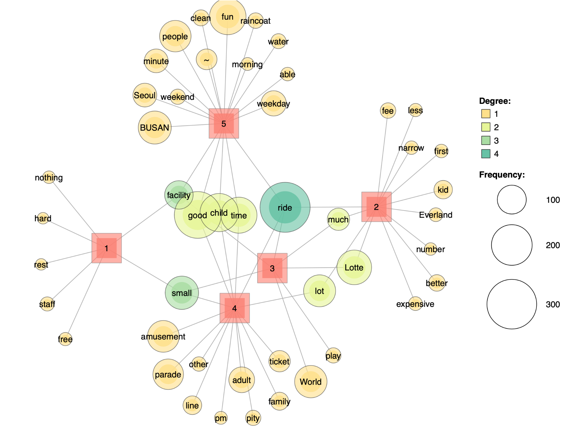

Overall glance

One sided :

- Nothing, hard, rest, staff, free.
- Fee, less, narrow, first, kid, everland, number, better, expensive
- World, play
- Amusement, parade, other, line, pm, adult, pity, ticket, line, family
- Busan, Seoul, weekend, minute, people, clean, fun, raincoat, morning, water, able , weekday.
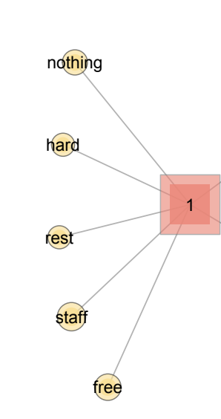
Rating reviews :

- Customers express utter disappointment due to limited options and high effort. Reviews mention nothing to do, difficulty navigating, and minimal rest areas. They highlight the lack of free amenities and criticise the staff's unhelpful service.

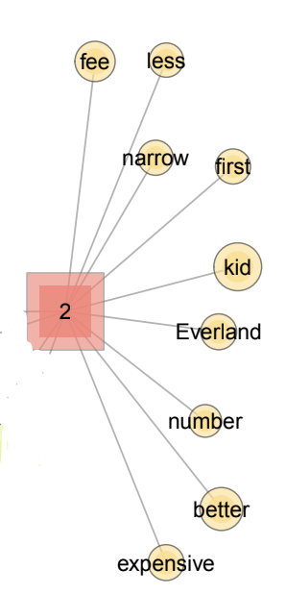

- Customers awarding 2 stars find it overpriced and lacking in variety, but see potential for improvement. Reviews mention high fees, limited attractions, and narrow walkways. They compare it negatively to Everland and suggest fewer rides with better quality. The "first time" phrase hints at disappointment based on expectation

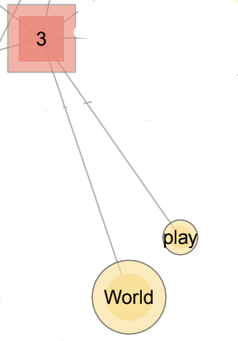
- While appreciating the global appeal ("World") and diverse play options ("play"), they express reservations about the park's limitations. Reviews mention the Lotte brand recognition but criticise high prices for a smaller facility. While rides provide amusement, some reviewers find them underwhelming.

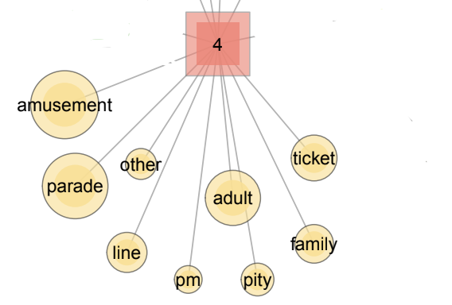
- Rated 4 for offering a good time for both adults and children, despite minor shortcomings and acknowledged its thrills and entertainment ("Amusement", "parade") but expressed reservations about logistics and value. LOTTE WORLD pleased visitors with good amusement options. While some noted the park's size, families enjoyed the family-friendly atmosphere, particularly the parades and after 3 pm entries. They lament the high ticket price and feel pity ("pity") for families navigating the crowds.

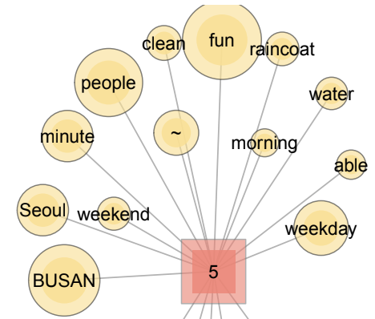
- Thrilled 5-star reviewers at Busan Lotte World rave about a vibrant weekend escape (Busan, weekend), praising efficiently managed crowds (minute, people) and impeccable cleanliness (clean). Reviews highlight thrilling fun (fun), especially on water rides (raincoat), and appreciate the early opening hours (morning) for a relaxed experience. They commend the park's adaptability (able, weekday), offering enjoyment even on weekdays.

Correlations:

1,5- facility
2,3,4,5- ride
1,3,4- small
4,5. Good, child, time

1 and 5 starred - facility:
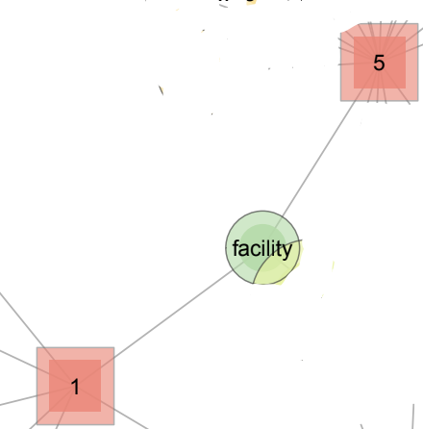
The word "facility" appearing in both rating 5 and 1 adds another layer to the story. In rating 5, it likely signifies visitors' appreciation for the park's well-maintained facilities, contributing to the overall positive experience. However, in rating 1, it might indicate specific concerns with certain facilities, like cleanliness issues or lack of accessibility, which contributed to their dissatisfaction.

2, 3, 4, 5 Starred - Ride:
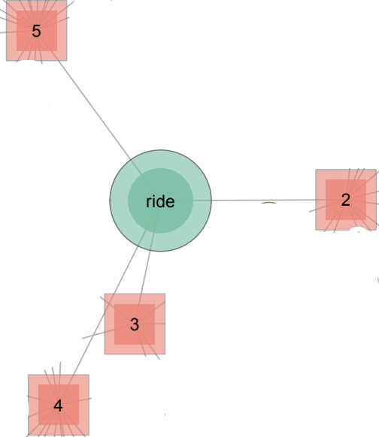
The prominence of "ride" across all ratings, from 2 to 5, underscores its central role in the visitor experience at Lotte World Adventure Busan. While it appears in the positive ratings (3, 4, and 5), hinting at overall enjoyment, its presence in rating 2 suggests potential areas for improvement. Analysing the specific words associated with "ride" in each rating could reveal whether visitors found the variety, thrill level, or wait times for rides to be satisfactory or lacking. This deeper understanding can guide the park in enhancing its ride offerings to meet diverse preferences and ensure a truly thrilling and satisfying experience for all riders.

1, 4, 5 starred - small:
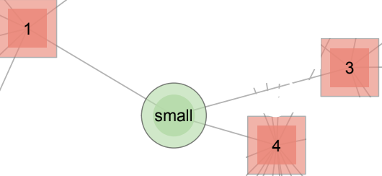

The word "small" surprisingly spans across ratings 1, 3, and 4, revealing its nuanced connection to visitor experience. In rating 1, it likely reflects dissatisfaction with the park's size or limited options. However, in ratings 3 and 4, it could have positive connotations, indicating manageable crowds, a pleasant atmosphere, or even a preference for less intense rides. This multifaceted meaning highlights the importance of understanding context and catering to diverse visitor preferences. By addressing concerns about size while emphasising the park's manageable scale and unique offerings, Lotte World Adventure Busan can attract a wider range of visitors seeking various experiences.

4,5 starred - good, child and time
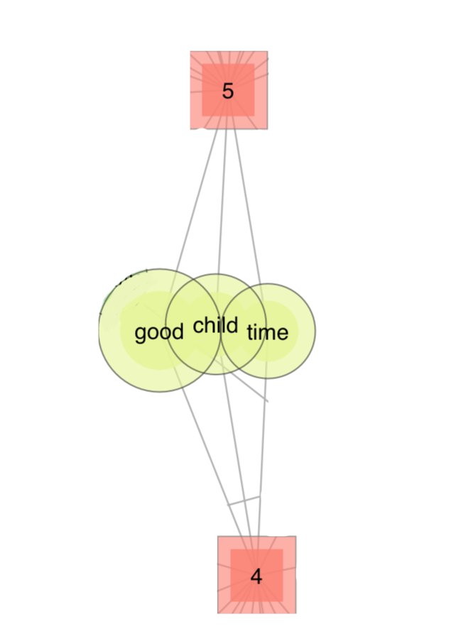
High-scoring reviews at Busan Lotte World (4-5 stars) celebrate the park's ability to deliver joyful moments for families ("good, child"). Customers commend quality time spent together, emphasising the positive experiences and lasting memories created. While some acknowledge potential downsides like wait times or crowds, these are overshadowed by the overall fun and satisfaction the park provides.

Statistics
After classifying the text, 887 data were sorted and collected for Lotte World in Busan, and rated 1 to 5 star ratings. The people who visited the Lotte World Park to enjoy it gave an average of 3.78 (Table 1) stars rating out of 5. Among them, 66% most honest reviewers gave 4 and 5 star ratings while 16% of visitors were not satisfied with the experience since they gave 1 and 2 star ratings.

Table 1

 | Ratings | Frequency | Percentage | Cumulative percentage
 | 1 | 88 | 9.9% | 9.9%
 | 2 | 58 | 6.5% | 16.4%
 | 3 | 151 | 17.0% | 33.4%
 | 4 | 243 | 27.4% | 60.8%
 | 5 | 347 | 39.2% | 100.0%
 | Totals | 887 | 100.0%
average score 3.78 ( std. dev. 1.3)

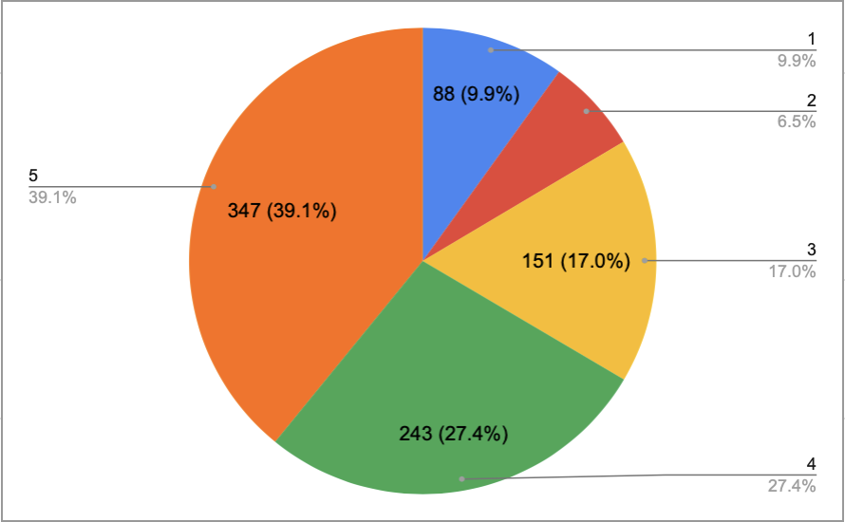

The pie chart above represents the proportion of ratings which give us the perception that 5 star rating is the highest among them covering almost 40% of the pie (347 people) , meaning that most people cherish this place. 2 and 1 star ratings contribute only 6.5% and 9.9% (58 and 88 people) respectively to the chart. So, overall satisfaction of visitors is still high.

Table 2 shows the 70 most frequent words relating to visitors' satisfaction that were extracted and ranked by their frequencies. The most frequent word was ‘ride’ ,with the frequncy of 305, as it plays crucial role to attract people. The words ‘good’ and ‘child’ were placed in the second and third positions respectively, with a frequency of 266 and 177 , meaning the Lotte World Adventure is a good place for children. Furthermore, the fourth and fifth positions were taken by the words ‘fun’ and ‘time’, with a frequency of 161 and 157 respectively, which means the visitors had fun there.’ It is also worth to point out that the visitors mentioned the word “weekday" considerably more compared to the word “weekend”, which means people prefer to visit The Lotte World Adventure on weekdays rather than weekends.

Table 2
 | Rank | Words | Frequency | Rank | Words | Frequency
 | 1 | ride | 305 | 36 | price | 36
 | 2 | good | 266 | 37 | pass | 34
 | 3 | child | 177 | 38 | swing | 33
 | 4 | fun | 161 | 39 | smaller | 33
 | 5 | time | 157 | 40 | bit | 32
 | 6 | park | 154 | 41 | food | 32
 | 7 | many | 153 | 42 | better | 32
 | 8 | small | 134 | 43 | big | 32
 | 9 | lot | 123 | 44 | giant | 31
 | 10 | amusement | 121 | 45 | clean | 30
 | 11 | people | 119 | 46 | new | 29
 | 12 | parade | 112 | 47 | entrance | 28
 | 13 | facility | 97 | 48 | fee | 28
 | 14 | place | 94 | 49 | raincoat | 28
 | 15 | hour | 84 | 50 | roller | 28
 | 16 | adult | 79 | 51 | performance | 27
 | 17 | weekday | 76 | 52 | pity | 27
 | 18 | day | 73 | 53 | play | 27
 | 19 | minute | 67 | 54 | size | 27
 | 20 | more | 67 | 55 | weekend | 27
 | 21 | attraction | 64 | 56 | coaster | 26
 | 22 | parking | 64 | 57 | water | 26
 | 23 | much | 59 | 58 | hot | 24
 | 24 | ticket | 54 | 59 | other | 24
 | 25 | few | 54 | 60 | short | 24
 | 26 | little | 49 | 61 | suitable | 24
 | 27 | discount | 42 | 62 | staff | 23
 | 28 | thing | 42 | 63 | nice | 23
 | 29 | line | 41 | 64 | expensive | 22
 | 30 | school | 41 | 65 | great | 22
 | 31 | kid | 40 | 66 | large | 22
 | 32 | long | 40 | 67 | student | 21
 | 33 | afternoon | 39 | 68 | able | 21
 | 34 | family | 38 | 69 | first | 21
 | 35 | restaurant | 38 | 70 | narrow | 21

Table 3 evaluates the Consumer satisfaction with 5 groups of categorised Reviews, such as Attraction-and-Entertainment, Family-and-Kids, Pricing-and-Discounts, Facility-and-Services and Time-and-Visitation.

1). As from entertainment category 1, train and theme were rated low as 2 ratings while ride, swing and parade were highly satisfied by the visitors and received 4.5 and 5 stars.

2). As the family sections come, “Adult and kids'” did not receive good ratings with 2.5 and 3 respectively, which seems there is not much to do for kids. However coming with family , it is always enjoyable with them and they also gave high ratings of 5.

3). As expected, discount and price sections were overall rated so low, no more than 3 ratings for all sections since it is not quite affordable to visit for normal people and having discounts is also rare there, therefore rated 2.

4). Service sections unexpectedly received overall less than average ratings since people are not satisfied with the staff along with complaining about the resting area giving 1 and 2 ratings respectively.

5). Visitations section received many complaints about the” time” and” day” with 1 stars ratings, meaning the place must be working night shifts as well but the people were happy from morning and weekend time shifts since they gave them 4.5 star ratings because of it.

Table 3
1. Attraction and Entertainment |  |  |  |  |  | 4. Facilities and Services:
 | Keywords | Stars | Frequencies |  |  |  | Keywords | Stars | Frequencies
 | ride | 5 | 305 |  |  |  | area | 4 | 20
 | swing | 5 | 33 |  |  |  | parking | 2 | 64
 | attraction | 3 | 64 |  |  |  | staff | 1 | 23
 | train | 2 | 16 |  |  |  | rest | 2 | 15
 | parade | 4.5 | 112 |  |  |  | raincoat | 5 | 28
 | theme | 2 | 15 |  |  |  | size | 4 | 27
 | performance | 4 | 27 |  |  |  | facility | 2.5 | 97
 | play | 3.5 | 27 |  |  |  | equipment | 4 | 17
 | roller | 4 | 28
2. Family and Kids: |  |  |  |  |  | 5. Time and Visitation:
 | Keywords | Stars | Frequencies |  |  |  | Keywords | Stars | Frequencies
 | family | 5 | 38 |  |  |  | time | 1 | 157
 | kid | 3 | 40 |  |  |  | minute | 5 | 67
 | baby | 5 | 18 |  |  |  | day | 1 | 73
 | school | 3.5 | 41 |  |  |  | hour | 1.5 | 84
 | student | 5 | 21 |  |  |  | pm | 3 | 19
 | adult | 2.5 | 79 |  |  |  | weekday | 4 | 76
 | people | 4 | 119 |  |  |  | weekend | 4.5 | 27
 |  |  |  |  |  |  | afternoon | 3.5 | 39
3. Pricing and Discounts: |  |  |  |  |  |  | morning | 4.5 | 19
 | Keywords | Stars | Frequencies |  |  |  | visit | 3 | 16
 | discount | 2 | 42
 | card | 1 | 20
 | price | 3 | 36
 | money | 2 | 15
 | fee | 1 | 28

The Descriptive Statistics for all 5 categories are presented in Table 4. It shows mean, median and Standard Deviation of each group. Customer satisfaction, which ranged from 1 to 5, had an average rating of 3.78. This suggests that most of the visitors had a satisfactory experience during their visit to Lotte World Adventure in Busan. In this regard, there are two categories with the highest and the lowest ratings which are worth mentioning. Category called “ Family and Kids” is the most effective for consumer satisfaction with the highest Mean(4), Median(4) and Standard Deviation with 1.04. We can also say that this category is the only one with the highest Minimum rating which is 2.5. On the other hand, “Pricing and Discounts” category has the poorest points of all which are Mean with 1.8, Median with 2, Standard Deviation with 0.84 and 1 minimum rating score.

Table 4
Descriptive analysis results
 | Categories | Mean | Median | Std.dev | min | max
 | Attraction and Entertainment | 3.67 | 4 | 1.15 | 2 | 5
 | Family and kids | 4 | 4 | 1.04 | 2.5 | 5
 | Pricing and discounts | 1.8 | 2 | 0.84 | 1 | 3
 | Facilities and services | 3.06 | 3.25 | 1.37 | 1 | 5
 | Time and Visitation | 3.1 | 3.25 | 1.49 | 1 | 5
 | Overall customer satisfaction | 3.78 | 4 | 1.29 | 1 | 5

Overall
Regarding the data that we provided above, here are some issues which visitors are facing:

- Facilities and Services:
  - "Area" has the lowest star rating (2 stars) with 4 frequencies, indicating potential dissatisfaction with the overall space or layout of the park.
  - "Parking" has a low rating (2 stars) with 2 frequencies, suggesting parking might be inconvenient or inadequate.
  - "Staff" and "Restroom" have ratings of 1 and 2 stars respectively, highlighting potential issues with staff helpfulness or restroom cleanliness/condition.
- Pricing and Discounts:
  - "Price" has a rating of 3 stars, suggesting that ticket prices might be a concern for some visitors.
  - "Discount" has a low rating (2 stars), implying that available discounts might not be perceived as valuable or attractive.

Potential Solutions:

- Facilities and Services:
  - Improve park layout or offer designated spaces for different activities to address concerns about crowded or unclear areas.
  - Expand parking options or implement better parking management strategies to ease parking difficulties.
  - Train staff on customer service best practices and address any underlying issues impacting their helpfulness.
  - Improve restroom cleanliness, maintenance, and accessibility to address hygiene concerns.
- Pricing and Discounts:
  - Consider offering more ticket tiers or discounts catering to different budgets and demographics.
  - Highlight the value proposition of existing discounts and make them easily accessible to potential customers.

Conclusion
Consumers' opinions can easily either improve or disrupt the park's reputation. This Cona analysis that we did for Busan Lotte world will enable us to see which side is in need of improvement, which side lacks the consumer satisfaction and needs to be dealt with immediately while which parts are most loved by visitors and that must be kept in this process. Turning it into descriptive statistics is for even better understanding of its problems and enhancement with numbers that can lead us to more clear answers. More or less, this report must have informed us about the reviews of the park and their perks along with the good news that someone will eventually obtain some knowledge about the approach and the park.

References

Google Search
Google Bard
Google Maps

